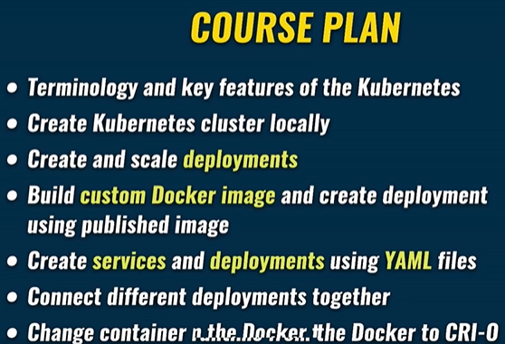

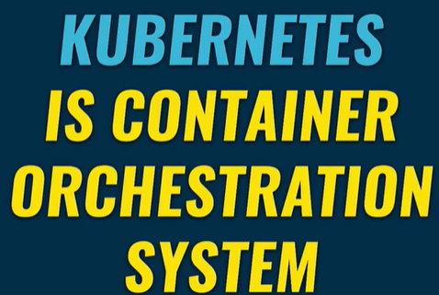

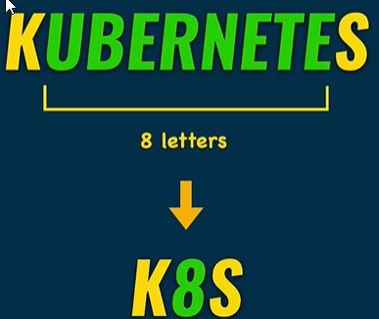

Using docker you could create a container on any computer. For creating multiple containers on different servers/computers you could get into trouble. Kubernetes allows that, in physical or virtual servers.

Kubernetes takes care of the automatic deployment of the containerized services across different servers.

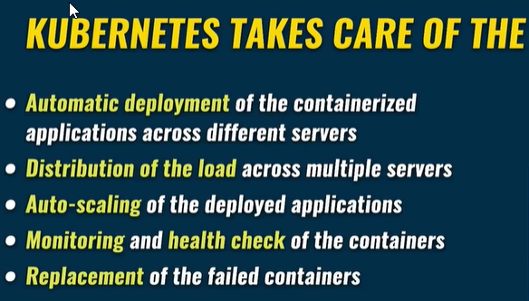Distribution of the load across different servers.

Autoscaling of the deployed applications.

Monitoring and health check of the containers.

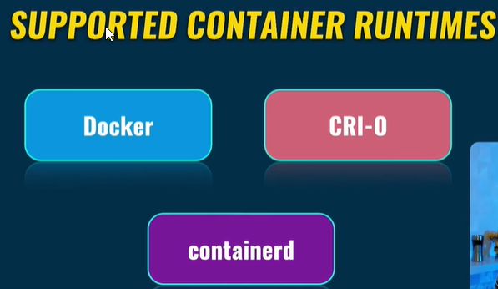Replacement of the failed containers.

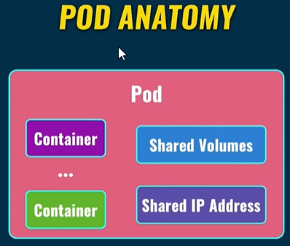Thus Kubernetes can run without Docker at all.

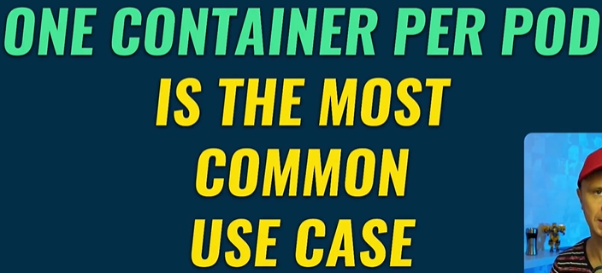

Containers are inside the pod. All containers inside the pod share the same volumes and the same IP Address.

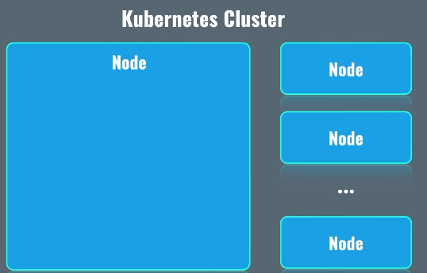One pod: One server, more servers not possible.

Kubernetes Cluster consist of nodes, nodes are nothing but server either bare-metal or virtual server.

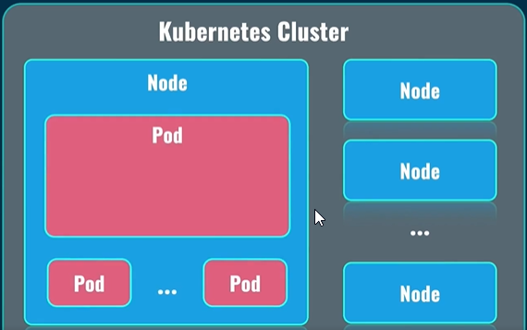Usually nodes which are in the same Kubernetes cluster, are located close to each other.

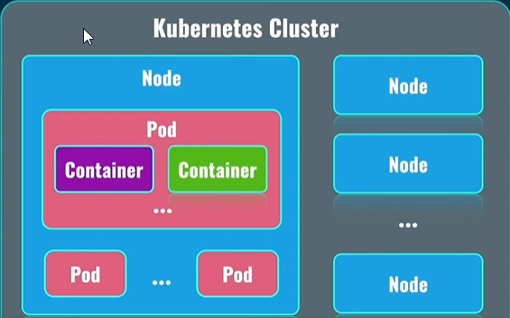Inside of the nodes, there are pods. Pods are the again, smallest possible unit in Kubernetes.

Inside the pods, there are containers, usually single containers per pod. Such pods are created on different nodes. All of this is done automatically for you. Your job is to create such nodes, and form clusters, based on those nodes. Nodes will not automatically form cluster without intervention.

But after such intervention, everything will be automated. Kubernetes will automatically form pods on different nodes.

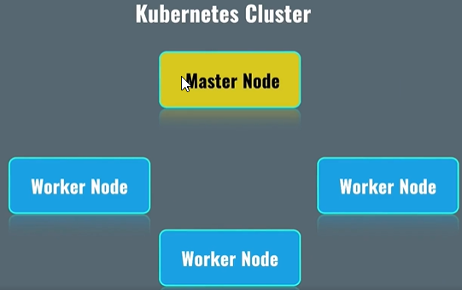How the nodes communicate with each other and how are they managed:

Master Node’s job to manage worker nodes. Distribute load across worker nodes. All pods related to your applications are deployed on worker nodes. Master Nodes work on system pods, which are responsible for actual work on system pods in general.

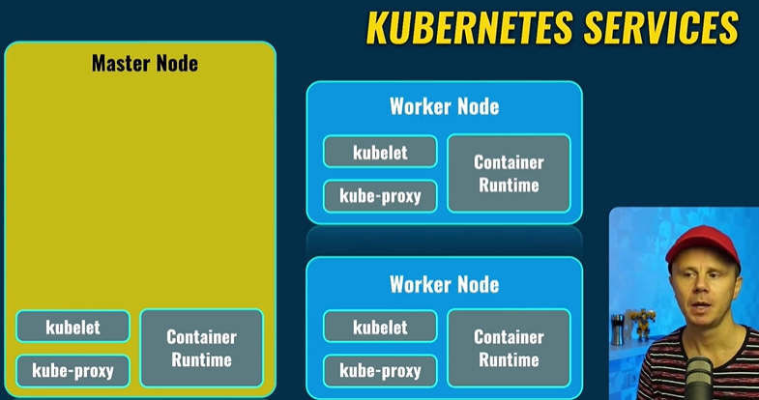Kubernetes Services:

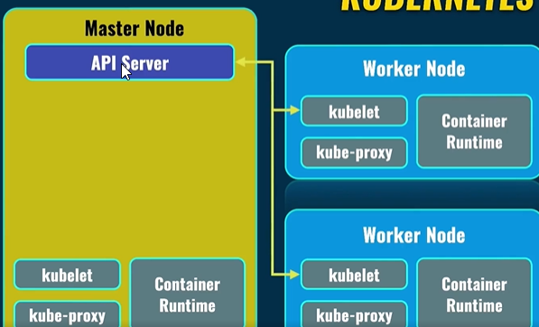Container Runtime: It runs actual containers inside of each node. Some container runtimes are docker, crio and container-d.

Kubelet: Communicates with API Server service in the master node. API Server service is the main point of communication between different nodes and inside of each node in the Kuberenetes world.

Scheduler: Load distribution.

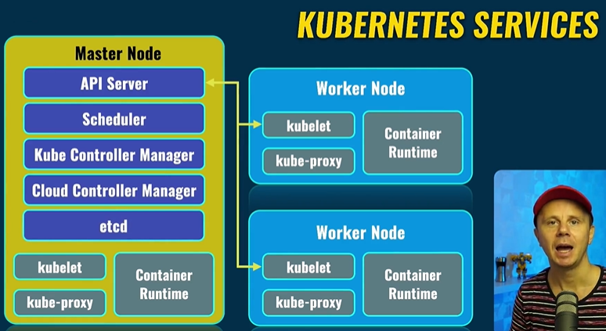Cloud Controller Manager: Interact with the cloud provider.

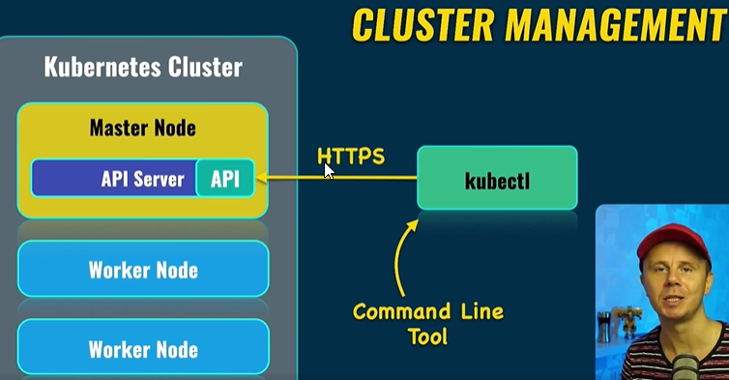

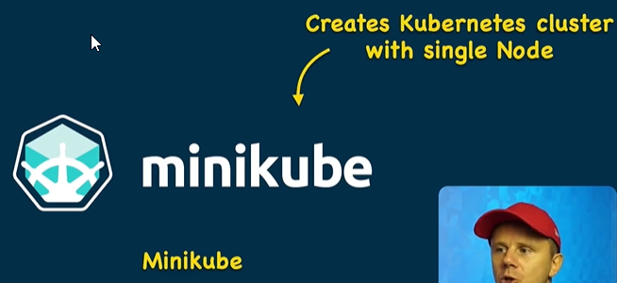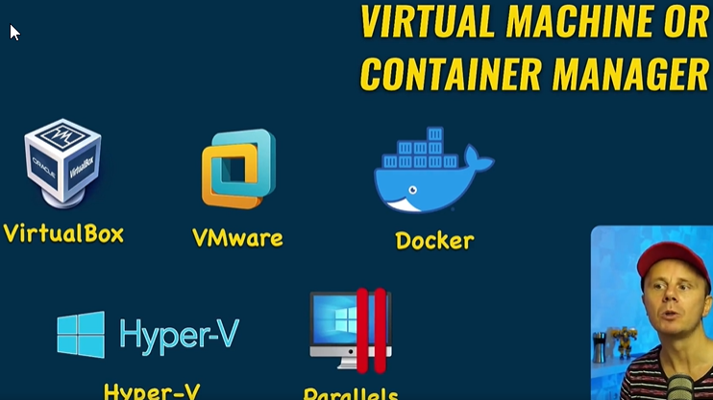Kubectl: Kube Control manages cluster.

Create Cluster for free, with one node, which will be both worker node and master node.

To run minikube successfully virtual machine or container manager is required.

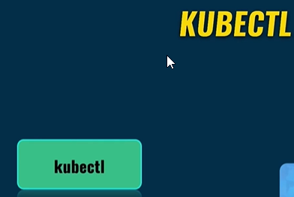Don’t use Docker since crio or containerd options not available.

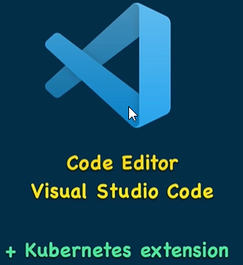

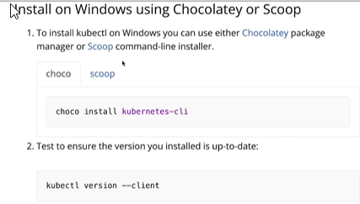

That’s all that is required, minikube, cubectl and VS Code.

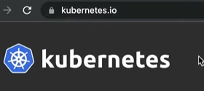

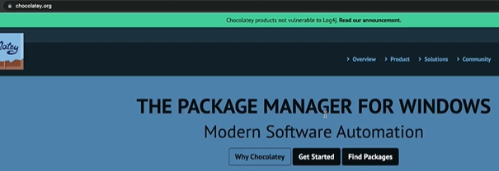

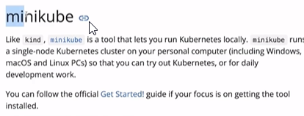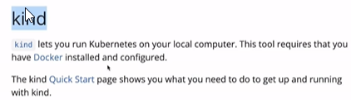

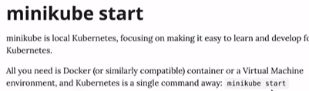

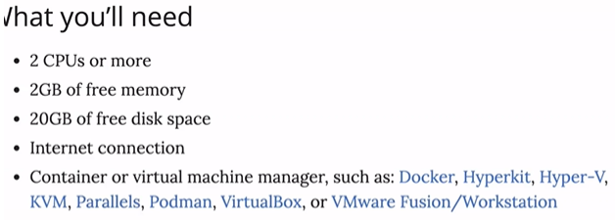

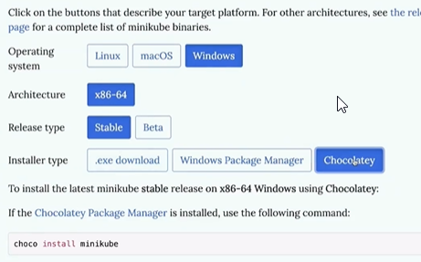

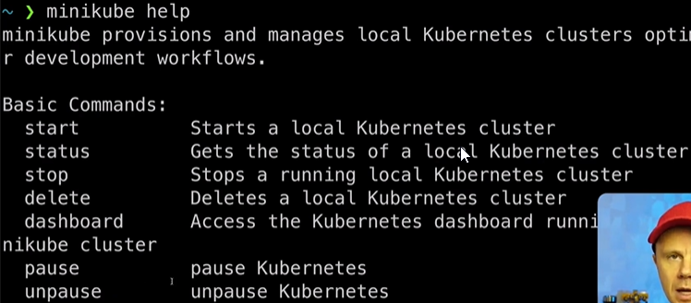

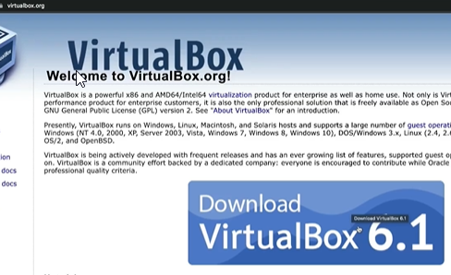

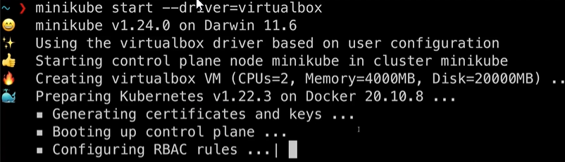

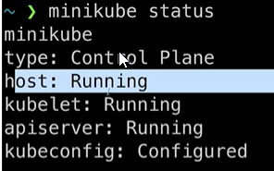

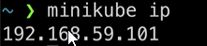

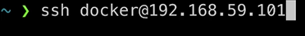IP assigned to the virtual machine which is running our Kubernetes node created by minikube.

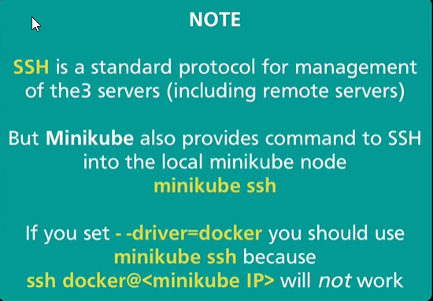

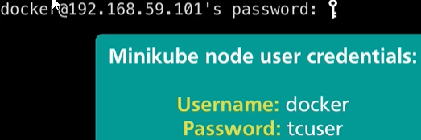

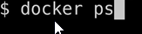

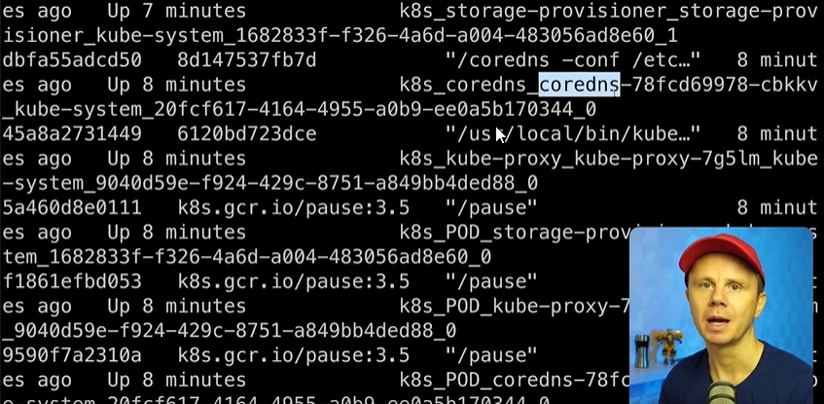Once inside the node, list the docker containers

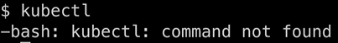

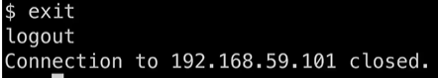Kubectl is not available inside the node.

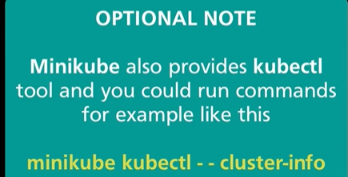That’s why exit the ssh connection.

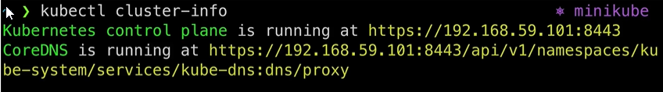

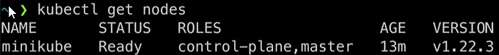

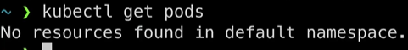

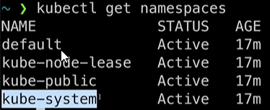

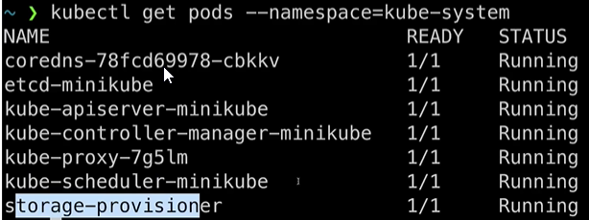

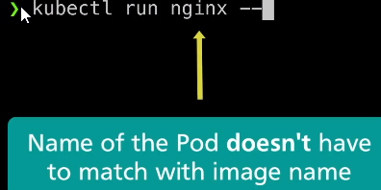System pods running on this master node.

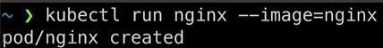

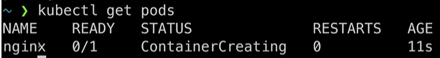Nginx is the name of the docker image which will be pulled automatically, and the new container will be created based on the image. This container will run inside of the Kubernetes pod.

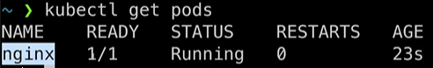

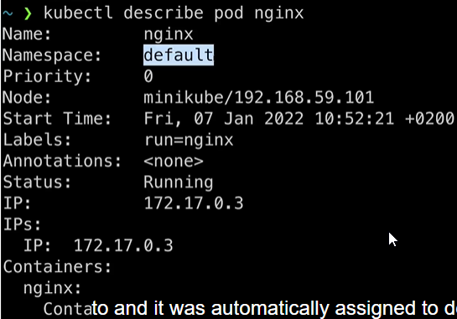Docker inside the Kubernetes node, fetches the nginx image from DockerHub, and creates corresponding container based on the image.

Node: Means where the specific pod was created.

Recall: Kubernetes distributes load across a cluster and selects specific node for a specific pod.

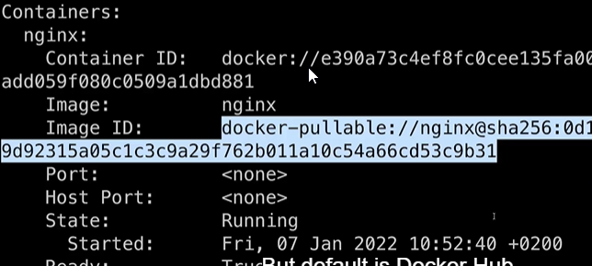But in order to access the pod, we will not be able to use the internal IP. We have to use services for that.

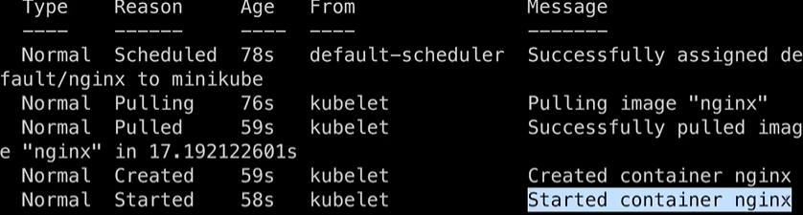

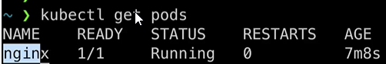



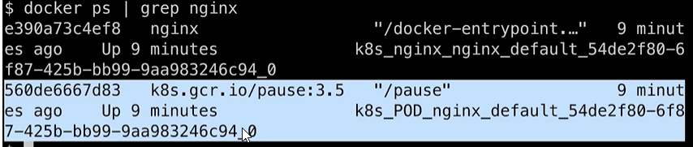

Two docker containers related to nginx.

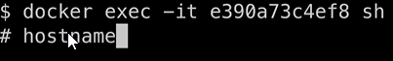The pause container is required to keep namespace of the pod.

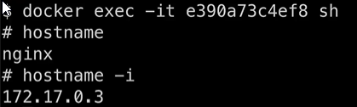Go inside of the container using: docker exec -it id_of_the_container

Check hostname and IP Address.

Now, to connect to the web server running inside of the container, using the above IP Address, we use the curl command.

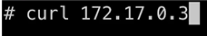

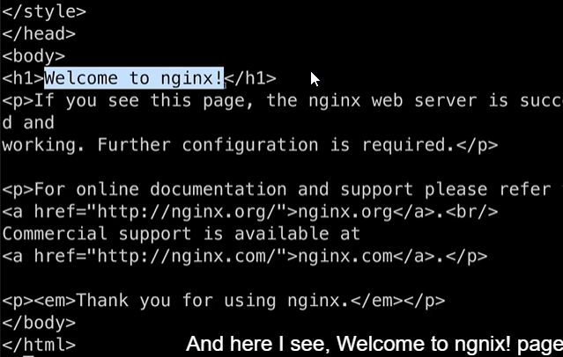



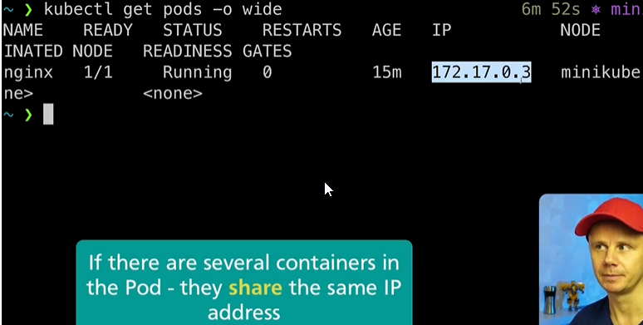Now we go out of this container, using the exit command, but we are still inside the Kubernetes node.

The IP Address is the internal IP address, and you will not be able to connect to the pod, from outside the cluster.

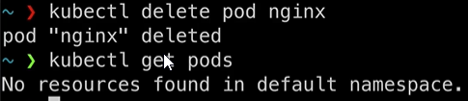We created just a single pod using the kubectl run command. It is not scalable.

Creating alias for kubectl command.



For Windows user git is required.

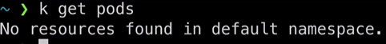



Most efficient way to create pods, when you are able to increase quantity of the pods, decrease quantity, modify configuration etc. is by using deployments.

Deployments will be responsible for creation of the actual pods. Note: All pods inside the deployment will be the same, exactly.

But you could create multiple copies of the same pod, and distribute the load across different nodes in the Kubernetes cluster.

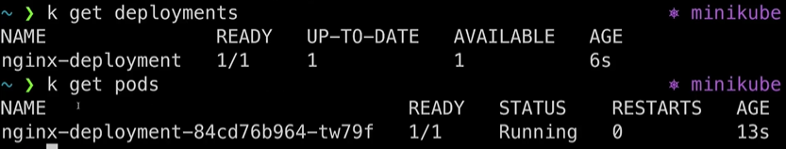

The given pod, is managed by the given deployment.

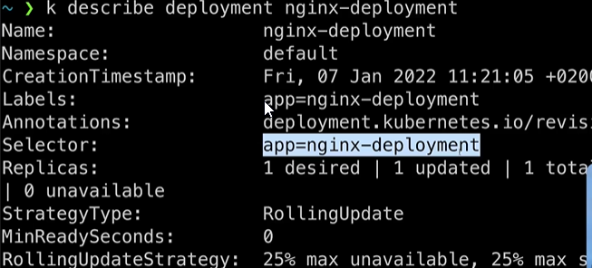

Selectors are way to connect individual pods to deployments.

Replica sets are a set of replicas for your application. Because there could be many pods inside the deployment and all of them are included in the replica set.

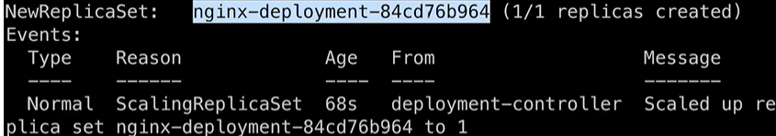



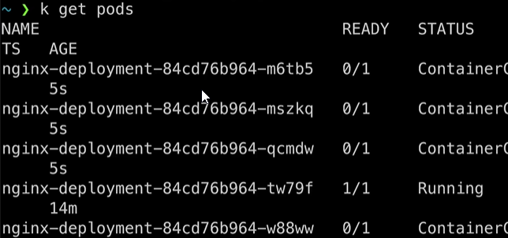

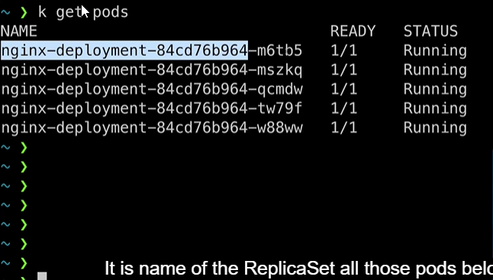

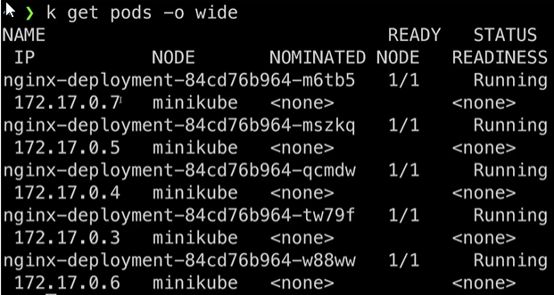

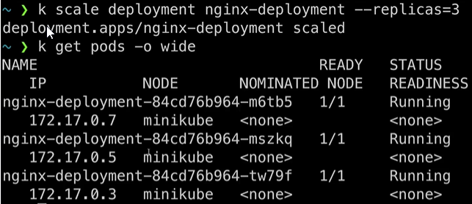

Scale down deployment from 5 to 3.

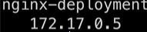

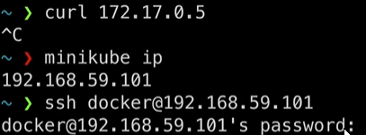



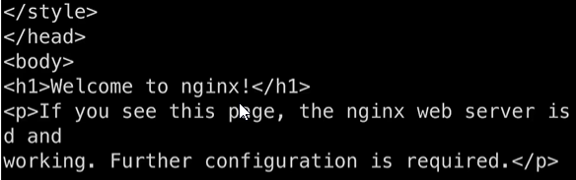

Now connected internally, once inside the node.



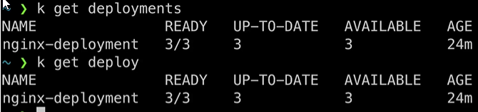

Let’s create a service for the second deployment.

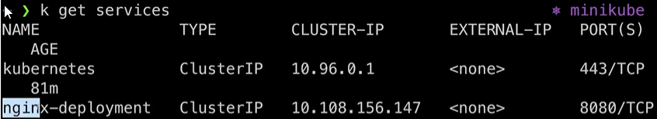nginx-deployment deployment exposed from internal port 80 to external port 8080

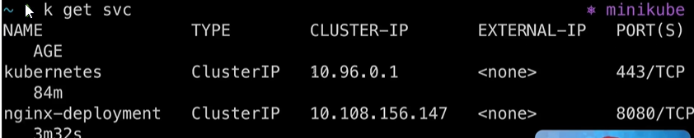Shorter Version:



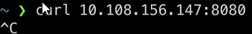

Not connecting, since cluster ip address is not available outside of the Kubernetes cluster.

But you are able to access cluster-ip from any node.

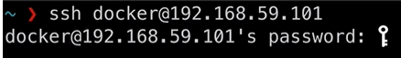

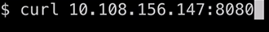Connect to node using ssh docker@ip_address_of_node

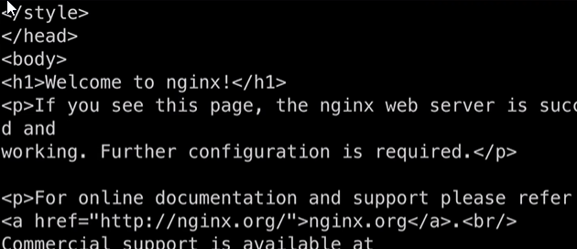

This answer was provided by one of the pods in the deployment.

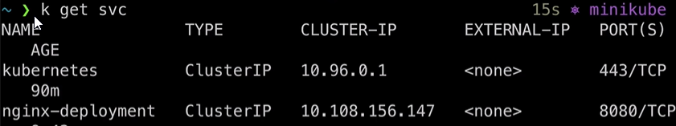Try and get answer from one of the pods in the deployment.

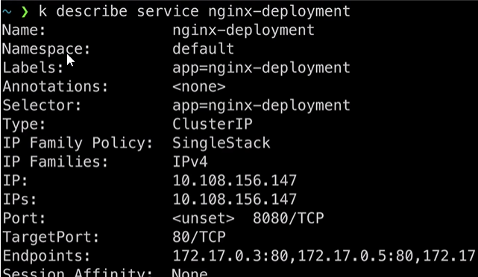

The load will be balance from the cluster ip to the 3 different ports in the endpoints.

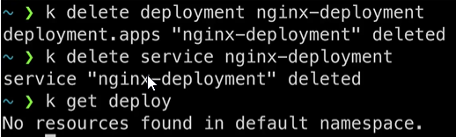







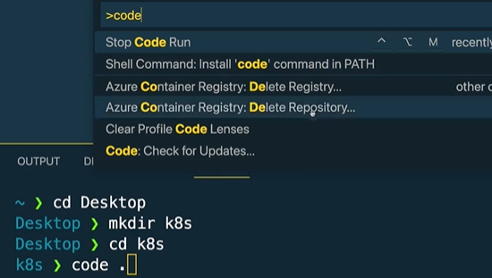

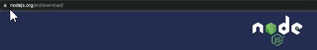Ctrl + Shift + P to install code if not available.

For npm

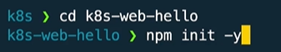

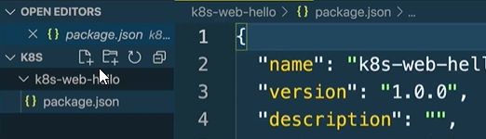code . transfers control to the newly created k8s folder. Create a web-hello folder inside that.

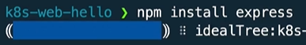New project will be initialized and package.json will be found.

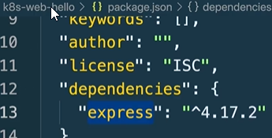

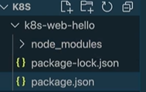Package was installed and dependencies was updated.

Delete the node modules folder, since we will not run this project locally with the help of node.

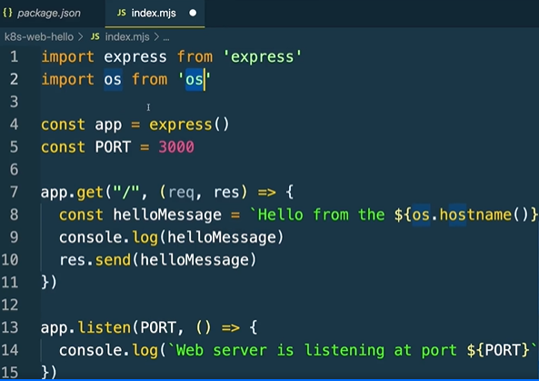Create a index.mjs file, because we will use ES6 modules syntax which is available in nodejs starting from v13.



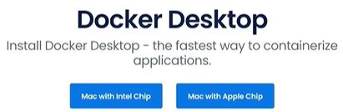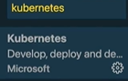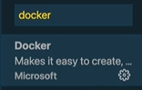

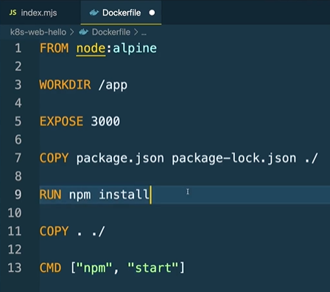

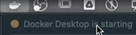Install Docker and Kubernetes extension.

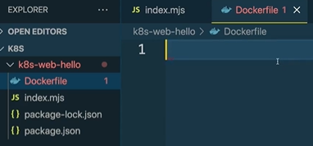

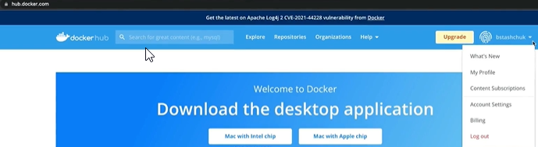Create a new Dockerfile.

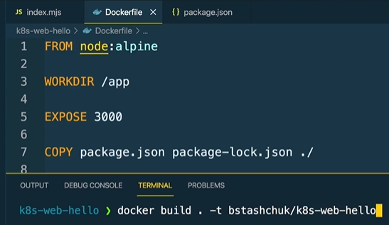Create your own docker hub account.

Build a Docker file, username of the docker hub account, repository name.

Finally, image was built.

Thus image is created in local machine.

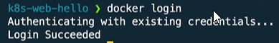

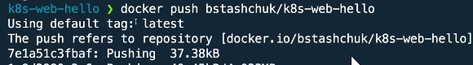

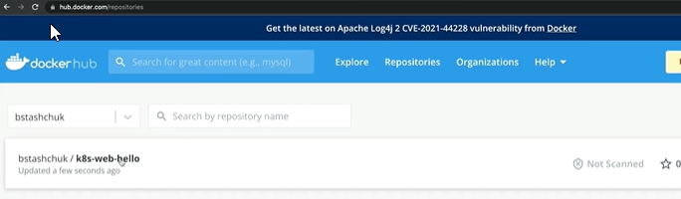Push the image to Docker Hub.

Reflecting on Docker Hub.

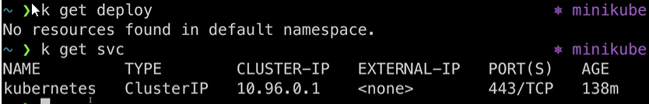





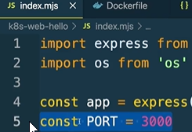

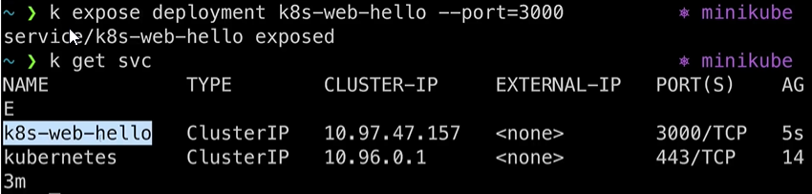

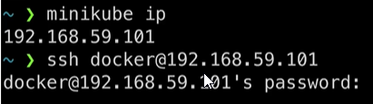kubectl expose deployment is used to create service.

Connect to the newly created service via minikube.

Connect now to the cluster ip using the curl command.

;echo move to new line.

Alias does not work in new tab.

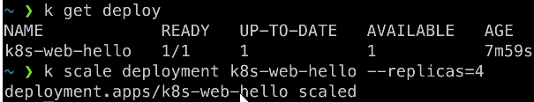

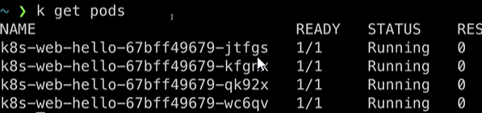Scale it to 4 replicas

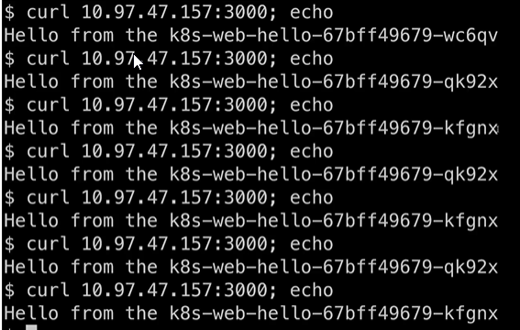

We see each time we get response from different pods.

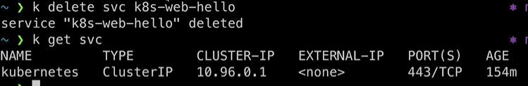

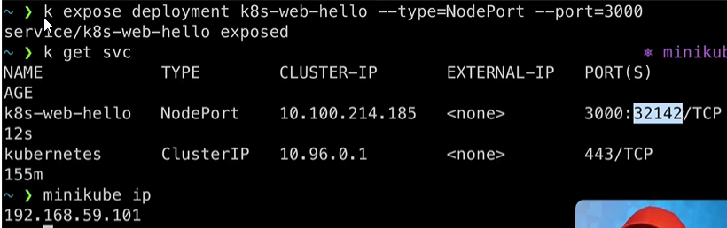

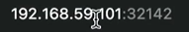

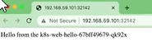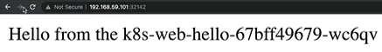Connect from external, using the IP and the port number.



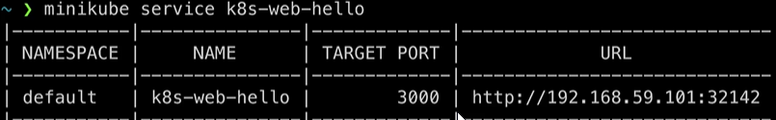



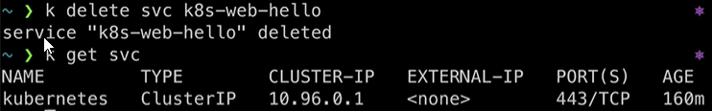

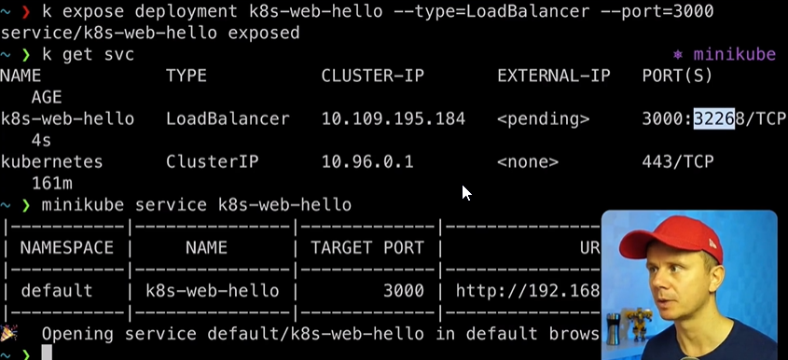

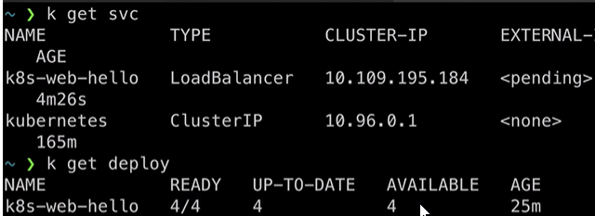

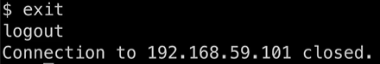

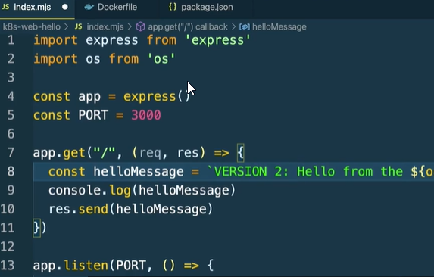

Modify the index.mjs file to version 2.

Build the image with the new tag in it.

We see almost all layers already exists and only one layer was pushed.

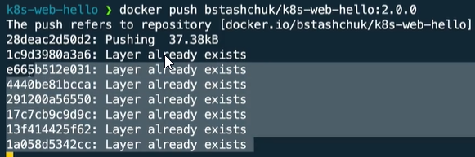

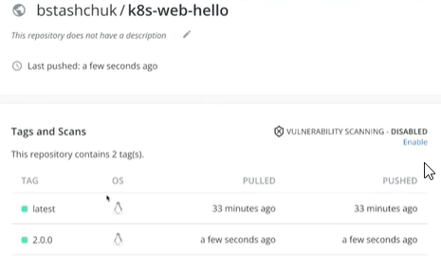

Now we deploy the new version of the image.

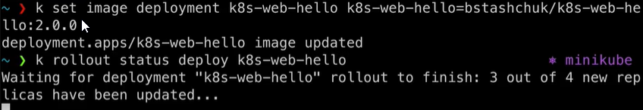Name of the deployment we would like to keep followed by the directory. After running this command, image will be changed, and rollout update will be started.

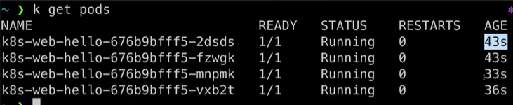



Previous pods terminated and new pods created, and in all those we are running the new version of our application.

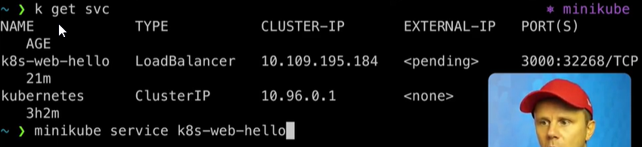

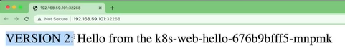With minikube service name we could open connection to one of the running pods.



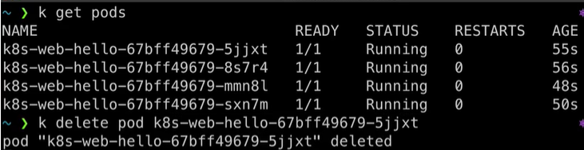

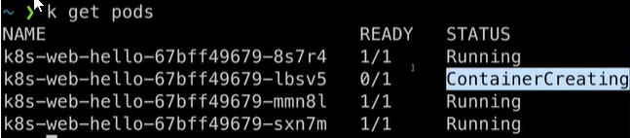

Kubernetes creates a new pod, by itself because no. of pods were pre-defined.

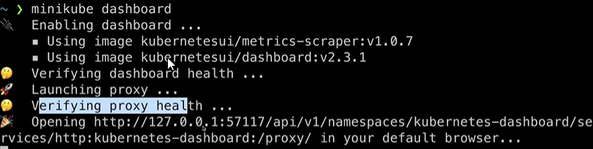

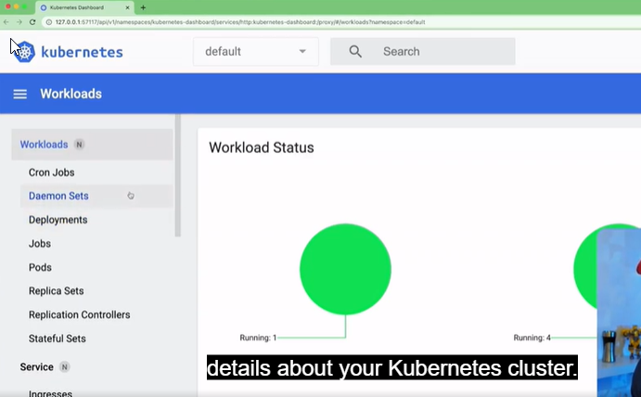

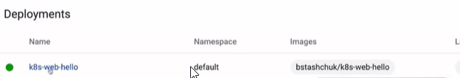

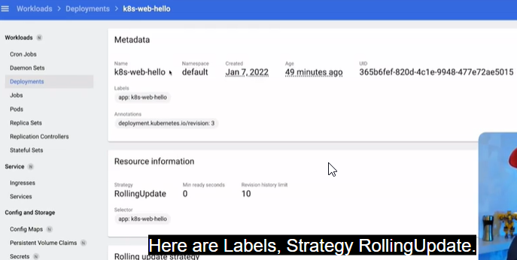

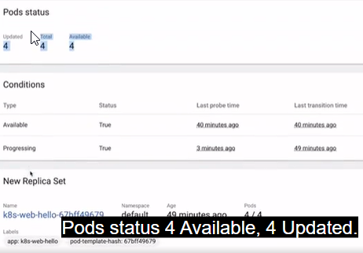

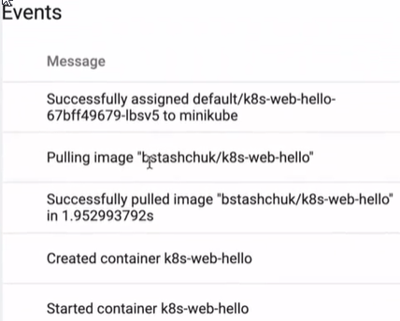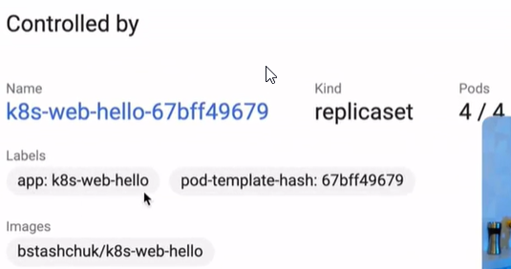

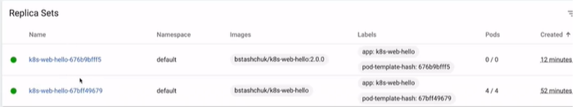Controlled by:

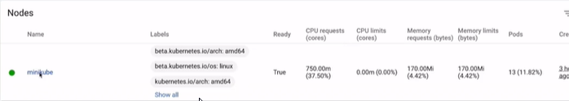Because we rolled back to the previous image using tag latest.



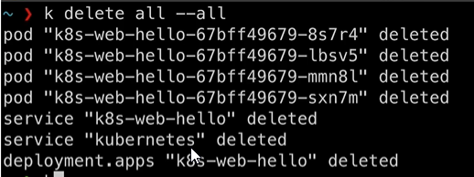We just used imperative approach to create deployments and services. We created them using different kubectl commands. But usually that’s not the way and in most cases a declarative approach is used.

All pods, service and deployments were deleted as well.

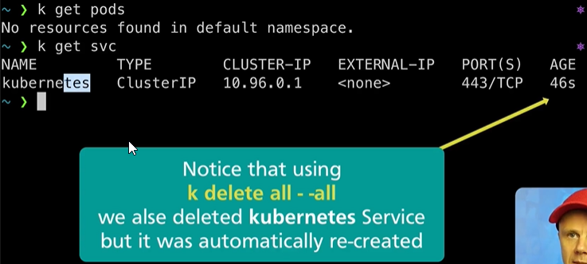

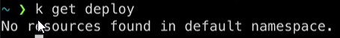

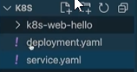Now we create a YAML configuration file for deployment and service.

Create 2 files, deployment and service.yaml

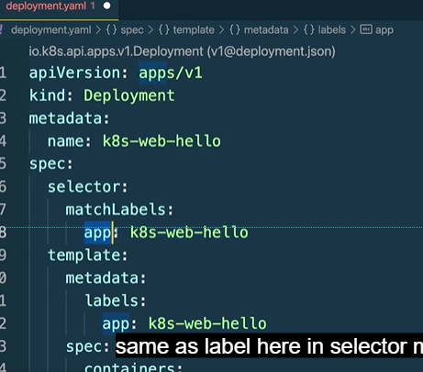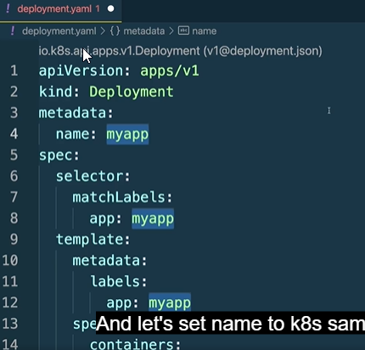Type Deployment and see the yaml conf file automatically created by you by the kubernetes extension.

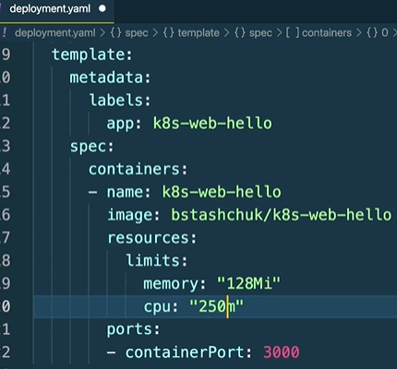

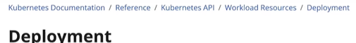



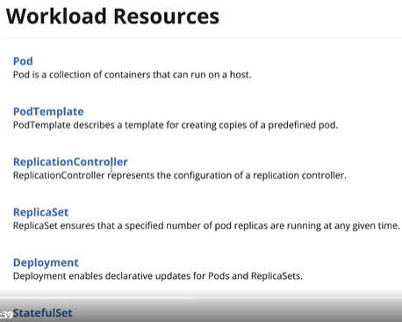

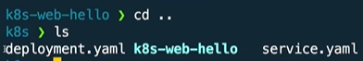

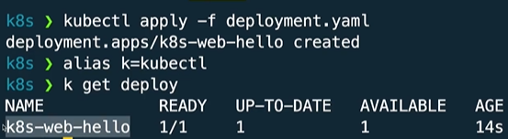

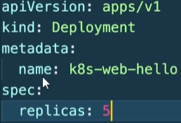

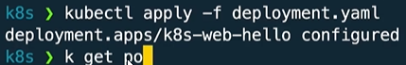We just use the apply command now.

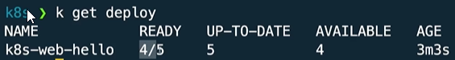

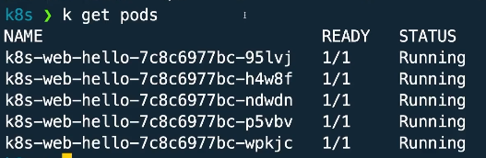

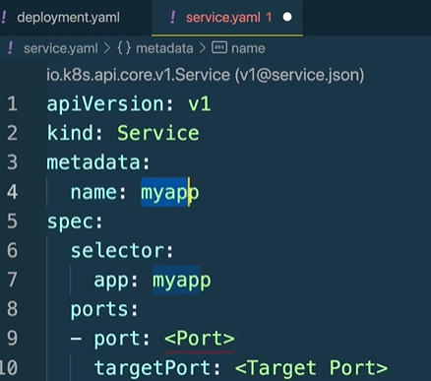



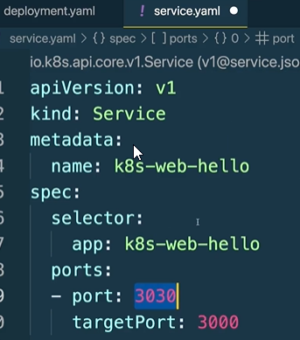Type service and the template will be created by the Kubernetes extension.

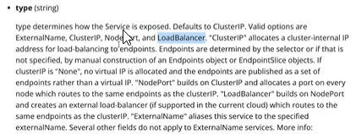

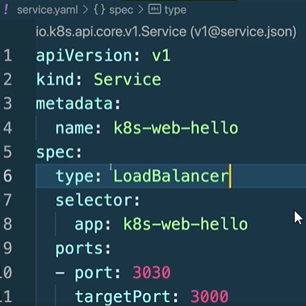Target port 3000 will be exposed to external port 3030.

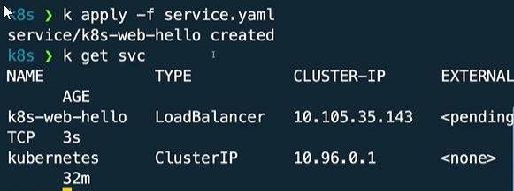

-f stands for file, spec: type: LoadBalancer service we add.

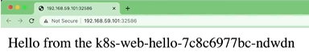



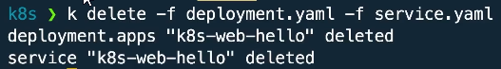Refresh, and we get response from another pod.

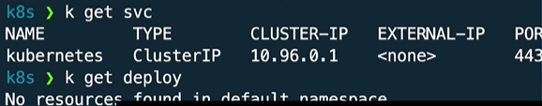Both deployment and service deleted.

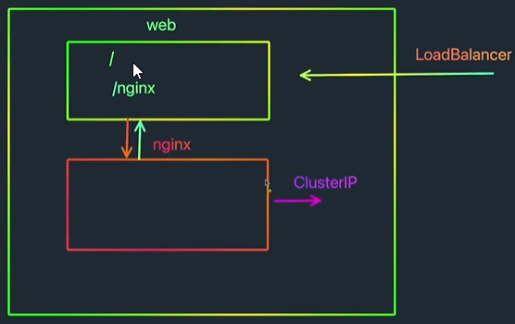

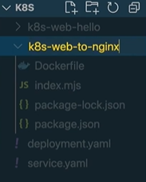

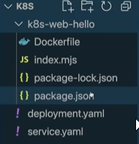

Create a copy of the k8s-web-hello folder.



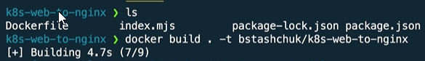

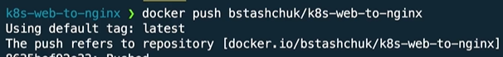



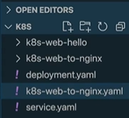

Create a .yaml configuration file for web-to-nginx.

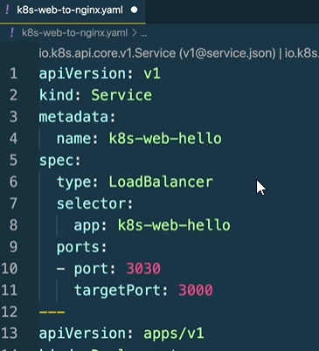

We paste both the contents of deployment.yaml and service.yaml file in this yaml file separated by ‘---’.

Select the name, Right-click -> Change all occurrences

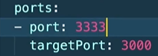

Change port

That’s it for the specification of deployment and service for new application.

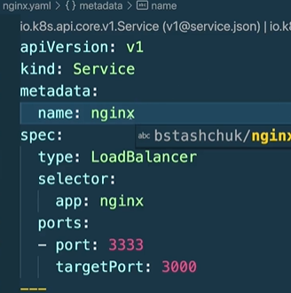

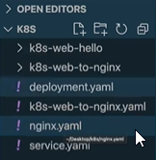

Copy the web-to-nginx file and paste and rename it as nginx.yaml.

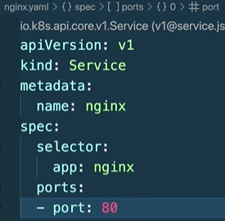Rename all occurrences of name to nginx.

Remove target port and set port to 80, this is where nginx will run our web server.

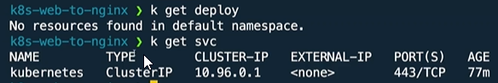

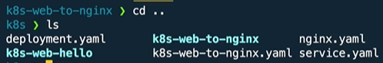

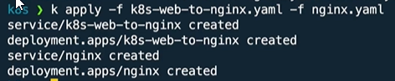Navigate to the folder where the new yaml configuration files are located.

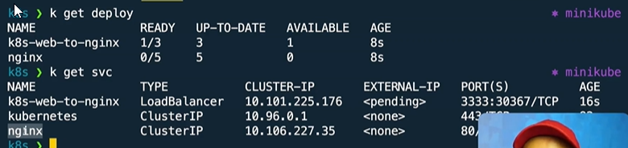

We will connect from k8s-web-to-nginx to nginx.

We could also utilize cluster ip to connect, but cluster ip is dynamic but the service ip is stable.

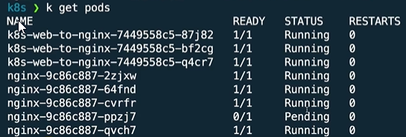

Now we connect from web deployment to nginx deployment.

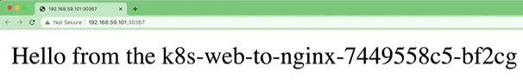

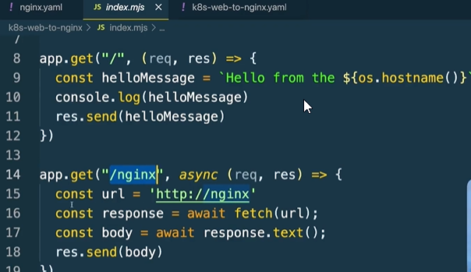

Recap that in the web-to-nginx file we have 2 endpoints, ‘/’ endpoint and the ‘/nginx’ endpoint.

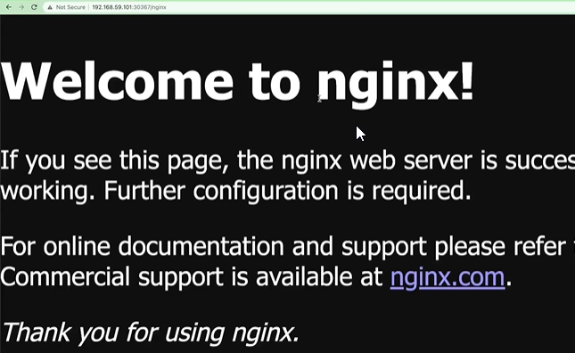2nd one will send a request to the nginx url and send the client proxy response from the other server.



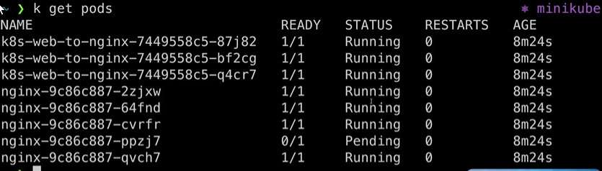

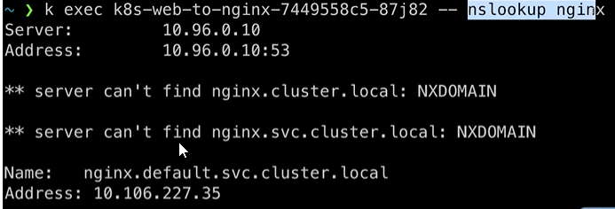

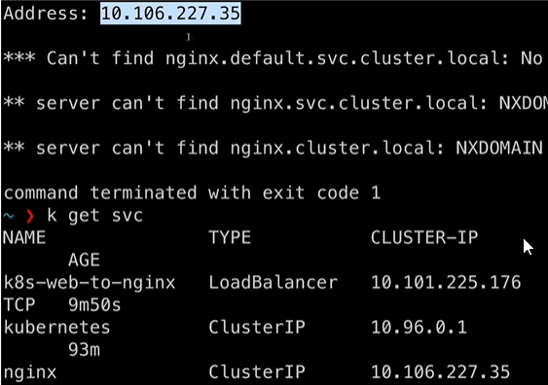 k exec name_of_the_pod

Kubernetes is able to resolve the ip to the cluster ip of the pod which belongs to other ip/ other service.



This will connect to nginx server and retrieve from it root webpage.

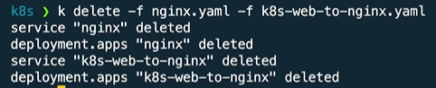

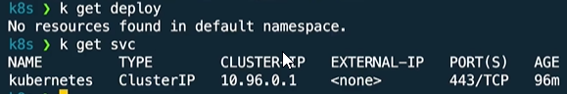

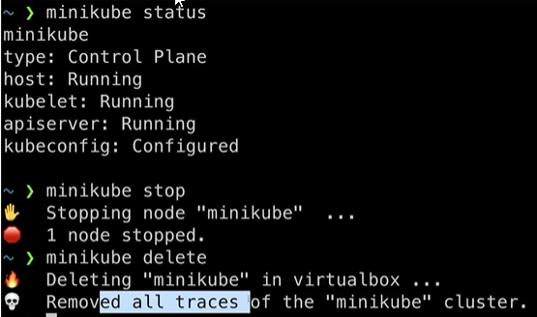

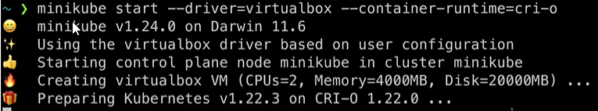Deleting minikube.

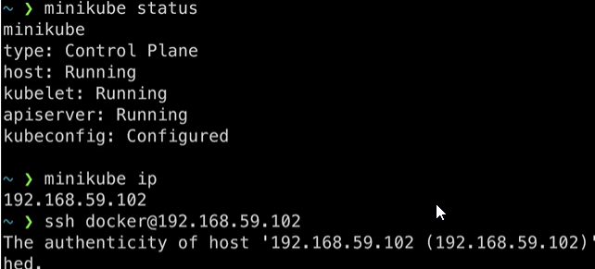

minikube status, ip, ssh docker.

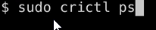



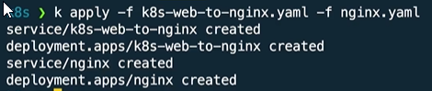

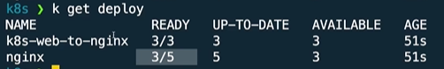

Now the containers are created by using crio container runtime.

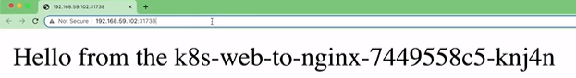k apply, minikube service



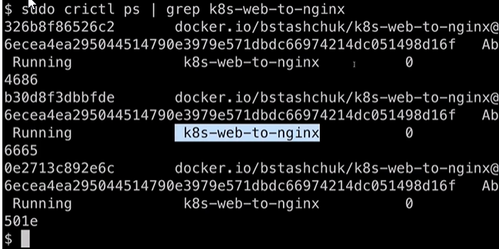

3 different containers.